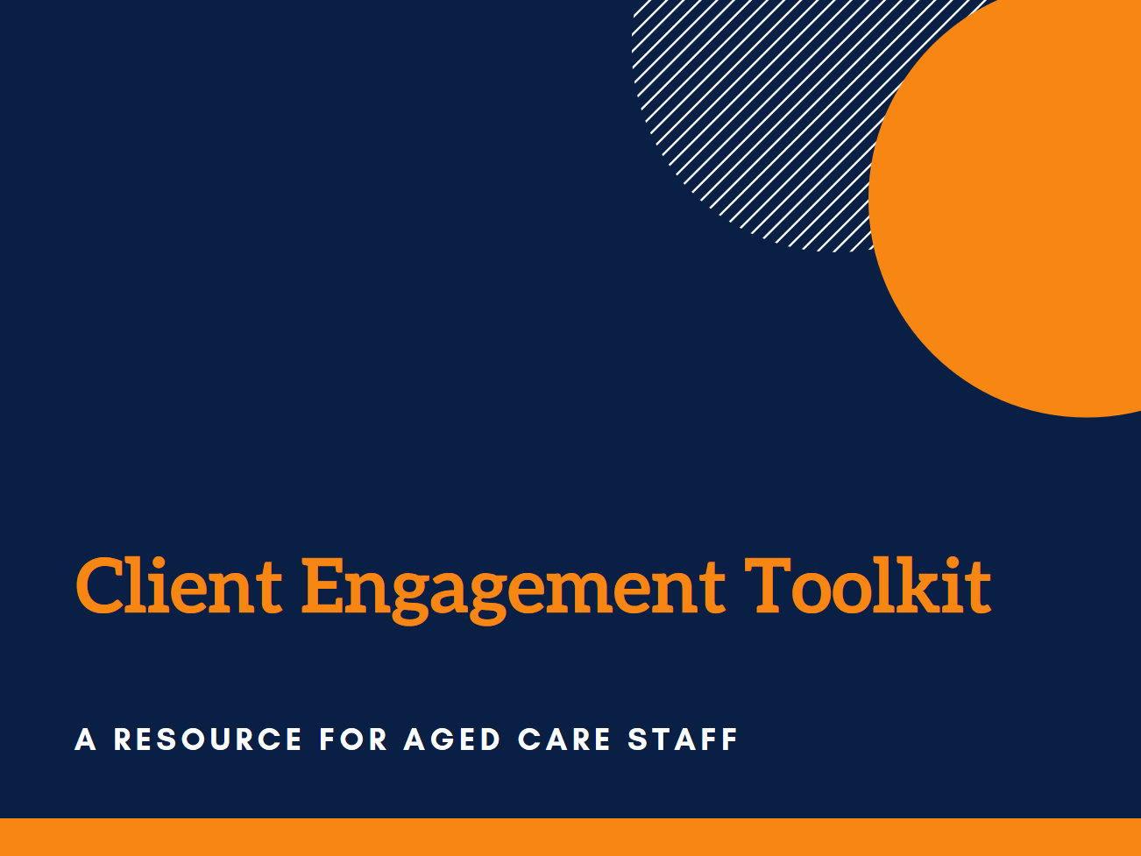
Author: Andrea Petriwskyj
© 2017 The University of Queensland, Brisbane, Australia
ABN 63 942 912 684, CRICOS Provider No: 00025B

This work is licensed under a Creative Commons Attribution-NonCommercial-NoDerivatives 4.0 International License. To view a copy of this license, visit https://creativecommons.org/licenses/by-nc-nd/4.0/.

There are a number of documents and practical guidelines that have been used to inform this framework. The sources used here are listed in the References section at the end of the Toolkit.

The contributions of Stephanie Power, Dr Ally Gibson, a large number of service staff and managers, and the panel of academic and practice experts to the development of the Toolkit are gratefully acknowledged.

This research was funded by an Australian Research Council Discovery Early Career Researcher Award (DE140101503).

Acknowledgments
Commitment to engagement
About the tools
Some examples

Tool 1- Need for Action
Tool 2- Action Planner

Tool 3- Monitoring and Evaluation

What is engagement?
Client engagement is about how we communicate and interact with clients, and how we involve them in decisions and planning. This can be individual, or it can relate to a whole service or even the whole organisation.
Engagement could involve direct discussion, collaboration, or partnership with one or many clients at any given time. However, it may not necessarily involve direct contact with an individual client. It could involve information sharing through marketing materials or information sheets, or the development of web services that clients may use, or that staff use to engage with clients directly.
If you see, talk to, or interact with clients, or if your role involves providing a service or system that clients use or interact with, then you are engaging with clients.
Engagement is the responsibility of all staff.
Clients have an important role in the planning, delivery, and evaluation of services, as well as in the direction and evaluation of their own care. Effectively engaging with clients is fundamental to fulfilling the organisation’s mission and values. Good engagement practice values the contribution of clients at every level of the organisation.
There are many important benefits to effectively engaging with clients. These include making sure services are appropriate, inclusive, and innovative, increasing satisfaction and uptake of services, and increasing support for client control and autonomy. Engagement is an investment in relationships, and this is important right from the very first contact with clients and stakeholders to help things go smoothly along the way.
Involving clients in decisions that affect them is required under Accreditation Standards and care legislation. An important part of the role of care services is supporting clients to have a strong voice.
Why do we engage?
There are many different forms engagement can take. It is important that organisations support innovation and the development of new ideas about the way they engage. All staff are encouraged to be proactive in seeking new ways to connect with clients.
All staff need to be supported to undertake client engagement and participation initiatives, and clients need to be supported to participate effectively in these initiatives. The efforts of staff and clients in contributing to these initiatives must be highly valued. Staff should be encouraged to help identify areas for improvement and to come up with ways to address any issues they see in the organisation.
It is important to provide feedback on what you have learned and how you have responded. This feedback needs to be given to clients and families, other stakeholders, and fed back up through the organisation. Staff need to be supported to learn from and provide feedback to stakeholders.

Commitment to engagement
Care organisations have many different stakeholders. As well as clients and their families, stakeholders may include information services, other service providers, policy makers, consumer groups, or representatives.
Clients and stakeholders are diverse. Different clients and stakeholders may need a different approach and engagement processes must be designed in a way that is inclusive of marginalised or isolated groups.
Engagement initiatives should be documented and evaluated to inform reporting for accreditation and monitoring. This should inform decision making as well as future engagement initiatives.

Care organisations should:
- Ensure clients have a say in their own care as well as how services are run
- Ensure participation opportunities for clients who will be affected by decisions are sufficient and appropriate
- Undertake regular and ongoing monitoring and evaluation of services and care
- Promote shared ownership and responsibility for decisions, monitoring, and evaluation of services
- Demonstrate openness to change and to the influence of clients and staff
- Show mutual respect and ensure the dignity of all involved
- Respect the diversity of people and their views, needs, and wishes
- Ensure fairness by making opportunities for engagement accessible to clients in practical ways that cater for varied (dis)abilities
- Ensure effective, transparent communication that allows all clients to be informed and voice their own opinions, ideas, or needs
- Openly report on how clients’ participation did or did not contribute to changes or decision making
To support engagement, they should:
- Provide staff and client training and education necessary to participate effectively
- Maintain on-going evaluation and monitoring of engagement

About the Toolkit

This set of tools is designed to guide you through the process of thinking about what client engagement looks like for you, what is working well, and what needs to be improved. The tools will help you to plan a project to make these improvements, and then implement and evaluate your project.
Your project could be designed to help other staff engage with clients and families better, or you might want to engage with clients and families directly yourself about an issue you know about.
Designing and implementing projects like this can be daunting, especially if you haven’t tried it before. These tools are designed to walk you through the process, and to make it simpler.
Using these tools will help you to plan and implement actions to address issues in your service, but will also help you to document what you are doing to address these problems. This is important for the organisation to be able to track what is happening throughout across the different services, and to show clients and accreditation bodies that staff and clients are involved in service improvement.

Wall snippets
A group of staff in residential care identified that their colleagues did not always take their time with residents and communicate clearly. They were concerned that staff did not always prioritise residents because they were rushing, and sometimes forgot that residents may have particular issues such as hearing impairments or dementia, which might affect their communication.
They designed a series of short informative “snippets” in the form of a sentence or poem. These addressed aspects of communication including respect, volume, tone of voice, special needs, and body language. Some gave information about hearing impairments and cognitive impairments to help remind staff about what they had learned in training. These snippets were placed on the staff room and nurses’ station walls and regularly rotated every couple of weeks.

Some examples
Dementia friendly cafe
Staff in community care wanted to provide a safe and comfortable space for clients with dementia and their caregivers to socialise and to receive and share information.
The service held a café day and invited clients and caregivers as well as staff from other dementia services. They served food and drinks and provided space for people to give and receive support and information.

Guide to Care
A group of staff in residential care recognised a need among the family members of their residents for support and ongoing information to help them feel engaged in the life of the service and in the care of their loved one. One of the major issues they identified was that families were overwhelmed with information and emotion when their loved one was admitted to care, and they often were not able to properly deal with all this information. This created issues later on.
The group decided that the existing resident handbook was not appropriate for family members, and that a short dedicated resource for families was needed. They designed a “Guide to Your Loved One’s Care” for family members and friends to keep, which provided the information they would need throughout their loved one’s time in the service.

How to use the tools

You can use these tools on your own or in a group. You may like to gather a team of people around you who share the same concerns and want to address the issues with you.
You can use the tools together in order, or you can take just one on its own to help you with your thinking about a project. You can fill in each tool at your own pace, save your copy of the toolkit, and come back when you are ready.
You should discuss your project idea with your manager before completing a full plan for your project. You should also work with your manager along the way to make sure that what you are planning is possible. Your manager can support and guide you in using the tools to design, implement, and evaluate your project.
In this electronic document, you can click through to each tool as you want to use it, or if you want to check something. Throughout the tools there are hints and tips to help you think through your project. You can find these by hovering your mouse wherever you see this symbol .

Once you have approval, you can start to implement your project according to your action plan.

Tool 1 – Need for Action is designed to help you to think about how you and other staff engage with your clients, and any issues you can see that need to be addressed.

Once you have your project underway, you can use
Tool 3 – Monitoring and Evaluation to help you think through how it is going, what you have achieved, and whether you need to change something.
You should use it multiple times throughout your project to help you reflect and evaluate and make changes along the way.
Before you implement your plan, you will need approval from your manager.

When you have identified something that you think needs to change, you can use Tool 2 – Action Planner to help you work out how to achieve it.

Tool 1

Need for Action

This tool will help you to think about how you and other staff engage with your clients, and any issues you can see that need to be addressed. You can complete it by yourself or as a group. This is also a useful tool to use in staff meetings to help facilitate discussion about issues staff are experiencing in their work.

Our current engagement with clients and their families
How we engage with clients and families:
Click here to enter text.

What we engage with them about:

How we find out what they think about how we engage:

What needs to be changed
What people have told us about how we engage:

Issues we have identified:

What we can do about it
Things we can change:

Things we need to escalate to a higher level in our organisation:

Tool 2
Action Planner

Once you have identified something about how staff engage with clients that you think needs to change, or you have decided you want to engage with clients directly about an issue you know about, you can use this tool to help you work out how to achieve it. You can use this to plan a project to engage with clients, or a project to help yourself and other staff engage with clients better.
The tool is designed to help you think through:
- what your project is and what you need to do to achieve it,
- who needs to be involved and why,
- how they will be involved, and
- how you will evaluate your project and tell people how it went.

Why we are doing this project
What is the issue about client engagement that we want to address?
Click here to enter text.
What do we want to achieve?

Does this issue relate to:
☐ engagement with individual clients about their own wants and needs,
☐ decisions or plans for our whole service, or
☐ decisions or plans for our whole organisation?
Who are the clients, staff, and other stakeholders affected by this issue?

Our ideas for what we can do
It is now time to brainstorm potential ideas to address the issue you would like to focus on. You may like to brainstorm with other colleagues to get their ideas. It helps to get all your thoughts down on paper, even if you don’t use them for your project. Remember, all ideas are useful!
As you think about your ideas, consider whether they are possible in your service or in the organisation, whether they will be effective to solve your issue, and whether they are feasible projects for you to do.
You may like to use a whiteboard or butcher’s paper for this process, or a mind mapping tool. You could create a mind map, a table, or a series of dot points – it’s up to you.
Once you have brainstormed some ideas, choose one to focus on and use the next pages to start developing up your project plan.

What we are going to do
What is our project idea?

How are we going to do it?

Who is going to do it
Who are our team members?

Who are our project leaders?

What will be each person’s role?

How often will we meet?

Who else needs to be involved
Clients
Which clients and/ or families need to be involved in our project? | Why do they need to be involved? | How do they need to be involved? | How will we invite them to participate? | What methods will we use to involve them?  For some ideas see  What engagement methods could I use?
Click here to enter text.

Staff
Which other staff need to be involved? | Why do they need to be involved? | What will be the roles of these staff in the project? | How will we invite them to participate? | How will we involve them?

External stakeholders
Does anyone outside of our organisation need to be involved?  If so, who are they? | Why do they need to be involved? | What will be the roles of these other stakeholders in the project? | How will we invite them to participate? | How will we involve them?

Practical Issues to Consider

Time
How long will our planned project take?
Click here to enter text.
Is there a time limit by which we need to be finished?

How much time will we need to allocate in our schedules to complete this project?

How much time will we be asking clients, staff, and stakeholders to give to participate in the project?

Getting people there
Are the people we want to involve close enough to us to participate in person? Do we need to find a way to involve them by telephone, internet or post? Are we, or they, going to need to travel?

Are any of the people we want to involve particularly difficult to reach? If so, what is our plan to address this?

What are the potential costs of participation to clients, staff, or stakeholders?

Do we need to reimburse them or provide an incentive?
☐ No
☐ Yes
If so, what will this be?

Making sure people can do what we’re asking of them
What knowledge and skills do we need to complete this project?

Do we have these skills and knowledge?
☐ No
☐ Yes
Do we need some training or extra support?
☐ No
☐ Yes
If so, what do we need and how will we access this?

Do we need special resources such as interpreters, communications aids, or special technology?
☐ No
☐ Yes
If so, how will we access these?

What knowledge and skills do our clients, staff, or external stakeholders need to participate in this project?

Do they have these?
☐ No
☐ Yes
Do we need to provide some training or extra support?
☐ No
☐ Yes
If so, what do we need to provide and how will we provide it?

Troubleshooting
This checklist is to get you thinking about some things that can create problems for effective engagement. You may not find they are all relevant to your project; however, this list will help you ensure you have considered all the potential problems you might encounter, before you start.
You can cross them off as you deal with them, and there is space below each for your own notes.

Being open and responsive
☐ What do we believe about clients’ views, and how they should express them? How will we make sure we are open to their contributions?
Click here to enter your notes
☐ What are the power differences between clients, other staff and ourselves that might affect our project?

☐ How can we make sure clients and other staff feel empowered to contribute?

☐ How will we make sure we are open to other staff members’ views and contributions and properly respond to these?

☐ How will we make sure we and our clients share an understanding and expectations about their participation and its outcomes?

Making people comfortable
☐ Do we know what attitudes and beliefs these clients and staff hold about participation?

☐ Do the people we want to involve have a good relationship with each other, or with our organisation?

☐ How will we address these issues to make sure everyone feels comfortable contributing?

Being inclusive
☐ How diverse are the clients, staff, and stakeholders we want to involve? How well do we understand these differences?

☐ How might these differences affect participation in our project?

☐ What is our plan to address these issues?

☐ Is there more we need to know about our clients, staff, or stakeholders before we can involve them effectively?

Ethics and legalities
Are there any potential ethical or legal issues (e.g. consent, privacy)?
☐ No
☐ Yes
If so, how will we deal with these?

Evaluation and reporting plan
How we will evaluate our project
Ongoing assessment of activities is important to contribute to performance monitoring and reporting. There are a number of key things to think about.
- It is important to consider why you are evaluating your project. Think about who will use the findings, and what they will be used for.
- Your evaluation can include both the effects of the project, and the process of the engagement you have undertaken. Your evaluation should also consider whether the engagement has been real and meaningful for the people you have involved.
- It is important to be clear about what change you expected to see, and who you expected it to affect. You might be interested in outcomes in areas such as: care; quality and safety; communication; efficiency and resources; appropriateness of services; health literacy; service accessibility; and timeliness of services.
You may want to include feedback from both those you involved and others who weren’t involved in your project.
- You need to decide how best to measure the change you expect to see. You might, for example, be interested in people’s verbal or written feedback about your project, or you might like to use service data, existing client survey data, clinical information, or specific measures designed for particular quality indicators.
- You need to consider whether you are looking for short term outcomes, long term outcomes, or both. This will affect then how you want to measure your outcomes.
Monitoring and evaluation should occur a number of times throughout the project.
- You need to think about who will conduct the evaluation. Consider what skills they will need, and what resources are needed. Power differences between the people involved – such as between clients, care and nursing staff, managers, and families – can affect how open people will be in their feedback. It may also be useful for different people to be responsible for different aspects or different stages of evaluation.

Why do we need to evaluate our project? How will the findings be used, and by whom?

Who will conduct the evaluation?

What do we want to know about how our project went?  What results or outcomes from our project do we want to measure? | How will we measure these outcomes? | When will we measure these outcomes? | How will we document what we find?

How we will report back about our project
How will we report back to clients, staff, and external stakeholders?

How will we report back to the organisation?

When will we report back on the results of our project?

What resources do we need to provide this feedback?

Budget

Direct costs
What will our project cost?

Budget item | Estimated or quoted cost
Describe item | $ Enter amount
 | $
 | $
 | $
 | $
 | $
 | $
 | $
 | $
 | $
Total | $ Enter total

How do we plan to access the funding we need?

Other resources
What other resources do we need?

How do we plan to access these resources?

What other “in kind” contributions will the organisation need to make?

Who needs to approve our budget?

When will we review our budget?

Our plan

Steps we need to take to complete our project | When it will be completed | Who is responsible
1. Describe Step 1 | Date | Team member
2. | Date
3. | Date
4. | Date
5. | Date
6. | Date
7. | Date
8. | Date
9. | Date
10. | Date

Approvals
☐ Have we checked the organisation’s guidelines and policies and is our project in line with the organisation’s position about clients and their contribution?

☐ Have we talked to our manager about our project and obtained their support?

Do we need any additional approvals?
☐ No
☐ Yes
If so, who do we need to ask?

Once you have made a plan and have all the approvals you need, you are ready to start your project!
Follow your plan, and remember to monitor your progress along the way.

You can use Tool 3 – Monitoring and Evaluation to help you monitor your progress.

Tool 3

Monitoring and Evaluation
Now that you have implemented your project, you can use this tool to help you think through how it went, and whether you need to change something. Evaluation is an essential part of your project, to help you see what you have achieved and what isn’t working.
It is also important to evaluate along the way to see what you have achieved and to celebrate what you’ve accomplished. It is important to celebrate your achievements during your project so that you can feel confident you are making a difference.
You can use this tool at multiple points in your project to help you reflect and evaluate and make changes along the way.
The tool is designed to help you think through:
- What happened and what you have achieved
- What you found out from what happened
- What you might need to do differently and what you should do next

Date of review
Enter the date.

What we did
Click here to enter text.

What happened
What we have achieved:

What didn’t go to plan:

What other people told us about how our activity went:

What we learned
New issues we identified:

New actions we need to take:

Budget review
Are we successfully sticking to our budget?
☐ Yes
☐ No
If not, what additional expenses do we need to include?

What we are going to do next | When it will be done | Who is responsible
 | Date  Date  Date  Date  Date  Date | Team member

References

Anthony P. & Crawford P. (2000). Service user involvement in care planning: the mental health nurse's perspective. Journal of Psychiatric and Mental Health Nursing, 7: 425–434.
Adams, J. R., & Drake, R. E. (2006). Shared decision-making and evidence-based practice. Community Mental Health Journal, 42, 87–105.
Branfield, F. & Beresford, P. (2006). Making user involvement work: Supporting service user networking and knowledge. York: Joseph Rowntree Foundation.
CommunityWest (2016). Step Forward Together Toolkit https://www.communitywest.com.au/cw-resources/co-production/step-forward-together-resources
Consumer Focus Collaboration (2000). Improving health services through consumer participation: A resource guide for organisations. Canberra: Commonwealth Department of Health and Aged Care.
Department of Health and Human Services Tasmania [DHHS] (2009). Your care, your say: Consumer and community engagement. Hobart: Department of Health and Human Services Tasmania.
Dialogue by Design (2012). A handbook of public and stakeholder engagement. London: Dialogue by Design.
Kings Fund (2013). Experience-based co-design. Available at https://www.kingsfund.org.uk/projects/ebcd
Health Canada (2000). Health Canada policy toolkit for public involvement in decision making. Ottawa: Minister of Public Works and Government Services Canada.
Health Service Executive (2010). Service user involvement methods: A guidance document. Dublin: Health Service Executive.
Home and Community Care (2009/2010). HACC Model for client engagement. Tasmania: Home and Community Care.
National Resource Centre for Consumer Participation in Health (2003). Organisational self-assessment and planning tool for consumer and community participation: A tool for organisations involved in health policy and education. LaTrobe University.
Queensland Health (2002). Consumer and community participation toolkit for Queensland Health staff. Queensland: Queensland Health.
Queensland Health (2010). Consumer engagement framework. Brisbane: Queensland Health.
Queensland Health (2010). Consumer and community engagement and patient involvement and participation in health service planning, delivery and evaluation. Brisbane: Queensland Health.
Queensland Health (2012). Developing a consumer and community engagement strategy: A toolkit for hospital and health services. Brisbane: Queensland Health.
Social Care Institute for Excellence (2007). Developing measures for effective service user and carer participation. London: Social Care Institute for Excellence.
Social Care Institute for Excellence (2008). The participation of adult service users, including older people, in developing social care. London: Social Care Institute for Excellence.
Tasmanian Council of Social Service (2012). Consumer engagement handbook for HACC services in Tasmania. Battery Point: TasCOSS.
World Café. Available at http://www.theworldcafe.com/

