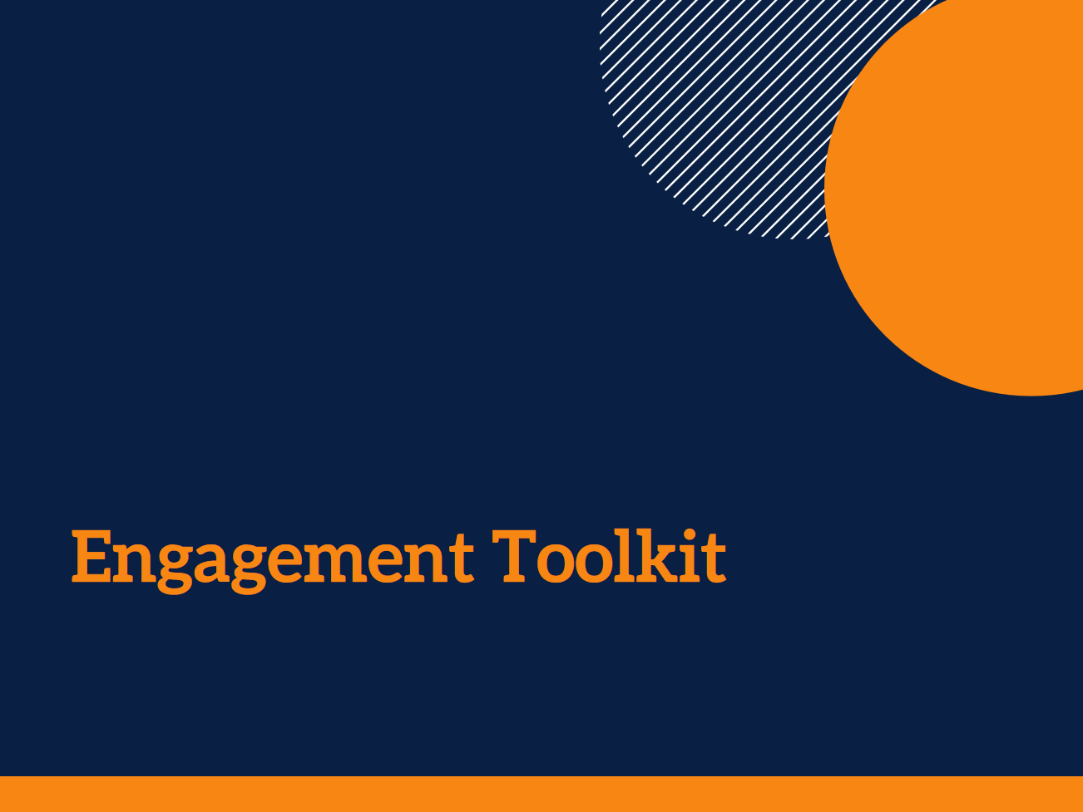

ACTION PLANNER

Author: Andrea Petriwskyj
© 2017 The University of Queensland, Brisbane, Australia
ABN 63 942 912 684, CRICOS Provider No: 00025B

This work is licensed under a Creative Commons Attribution-NonCommercial-NoDerivatives 4.0 International License. To view a copy of this license, visit https://creativecommons.org/licenses/by-nc-nd/4.0/.

There are a number of documents and practical guidelines that have been used to inform this Toolkit. The sources used here are listed in the References section at the end of the Toolkit.

The contributions of Stephanie Power, Dr Ally Gibson, a large number of service staff and managers, and the panel of academic and practice experts to the development of the Toolkit are gratefully acknowledged.

This research was funded by an Australian Research Council Discovery Early Career Researcher Award (DE140101503).

Acknowledgments

Once you have identified something about how staff engage that you think needs to change, or you have decided you want to engage with people directly about an issue you know about, you can use this tool to help you work out how to achieve it. You can use this to plan a project to engage with people directly, or a project to help yourself and other staff engage with particular stakeholders better.

The tool is designed to help you think through:
- what your project is and what you need to do to achieve it,
- who needs to be involved and why,
- how they will be involved, and
- how you will evaluate your project and tell people how it went.

Action Planner
Before you implement your plan, you will need approval from your organisation.

When you have identified something that you think needs to change, you can use Tool 2 – Action Planner to help you work out how to achieve it.

Why we are doing this project
What is the issue about engagement that we want to address?
Click here to enter text.
What do we want to achieve?

Does this issue relate to:
☐ engagement with individuals about their own wants and needs,
☐ decisions or plans for our whole service, or
☐ decisions or plans for our whole organisation?
Who are the people affected by this issue?

Our ideas for what we can do
It is now time to brainstorm potential ideas to address the issue you would like to focus on. You may like to brainstorm with other colleagues to get their ideas. It helps to get all your thoughts down on paper, even if you don’t use them for your project. Remember, all ideas are useful!
As you think about your ideas, consider whether they are possible in your service or in the organisation, whether they will be effective to solve your issue, and whether they are feasible projects for you to do.
You may like to use a whiteboard or butcher’s paper for this process, or a mind mapping tool. You could create a mind map, a table, or a series of dot points – it’s up to you.
Once you have brainstormed some ideas, choose one to focus on and use the next pages to start developing up your project plan.

What we are going to do
What is our project idea?

How are we going to do it?

Who is going to do it
Who are our team members?

Who are our project leaders?

What will be each person’s role?

How often will we meet?

Who else needs to be involved
Consumers
Which of the people using our services, their families or support people need to be involved in our project? | Why do they need to be involved? | How do they need to be involved? | How will we invite them to participate? | What methods will we use to involve them?  For some ideas see  What engagement methods could I use?
Click here to enter text.

Staff
Which other staff need to be involved? | Why do they need to be involved? | What will be the roles of these staff in the project? | How will we invite them to participate? | How will we involve them?

External stakeholders
Does anyone outside of our organisation need to be involved?  If so, who are they? | Why do they need to be involved? | What will be the roles of these other stakeholders in the project? | How will we invite them to participate? | How will we involve them?

Practical Issues to Consider

Time
How long will our planned project take?
Click here to enter text.
Is there a time limit by which we need to be finished?

How much time will we need to allocate in our schedules to complete this project?

How much time will we be asking each of the groups of participants to give to the project?

Getting people there
Are the people we want to involve close enough to us to participate in person? Do we need to find a way to involve them by telephone, internet or post? Are we, or they, going to need to travel?

Are any of the people we want to involve particularly difficult to reach? If so, what is our plan to address this?

What are the potential costs of participation to each of our stakeholders?

Do we need to reimburse them or provide an incentive?
☐ No
☐ Yes
If so, what will this be?

Making sure people can do what we’re asking of them
What knowledge and skills do we need to complete this project?

Do we have these skills and knowledge?
☐ No
☐ Yes
Do we need some training or extra support?
☐ No
☐ Yes
If so, what do we need and how will we access this?

Do we need resources such as interpreters, paid support people, communication aids, hearing loops, translated or large print information, or special technology?
☐ No
☐ Yes
If so, how will we access these?

What knowledge and skills do our different stakeholders need to participate in this project?

Do they have these?
☐ No
☐ Yes
Do we need to provide some training or extra support?
☐ No
☐ Yes
If so, what do we need to provide and how will we provide it?

Troubleshooting
This checklist is to get you thinking about some things that can create problems for effective engagement. You may not find they are all relevant to your project; however, this list will help you ensure you have considered all the potential problems you might encounter, before you start.
You can cross them off as you deal with them, and there is space below each for your own notes.

Being open and responsive
☐ What do we believe about the value of consumers’ views, and how they should express them? How will we make sure we are open to their contributions?
Click here to enter your notes
☐ What are the power differences between the people we are asking to participate and ourselves that might affect our project?

☐ How can we make sure all the participants feel empowered to contribute?

☐ How will we make sure we are open to other staff members’ views and contributions and properly respond to these?

☐ How will we make sure everyone shares an understanding and expectations about participation and its outcomes?

Making people comfortable
☐ Do we know what attitudes and beliefs the people we want to involve hold about participation?

☐ Do the people we want to involve have a good relationship with each other, or with our organisation?

☐ How will we address these issues to make sure everyone feels comfortable contributing?

Being inclusive
☐ How diverse are the people we want to involve? How well do we understand these differences?

☐ How might these differences affect participation in our project?

☐ What is our plan to address these issues?

☐ Is there more we need to know about each of these people before we can involve them effectively?

Ethics and legalities
Are there any potential ethical or legal issues (e.g. consent, privacy)?
☐ No
☐ Yes
If so, how will we deal with these?

Evaluation and reporting plan
How we will evaluate our project
Ongoing assessment of activities is important to contribute to performance monitoring and reporting. There are a number of key things to think about.
- Your evaluation can include both the effects of the project, and the process of the engagement you have undertaken. Your evaluation should also consider whether the engagement has been real and meaningful for the people you have involved.
- It is important to be clear about what change you expected to see, and who you expected it to affect. You might be interested in outcomes in areas such as: care; quality and safety; communication; efficiency and resources; appropriateness of services; health literacy; service accessibility; and timeliness of services.
You may want to include feedback from both those you involved and others who weren’t involved in your project.
- You need to decide how best to measure the change you expect to see. You might, for example, be interested in people’s verbal or written feedback about your project, or you might like to use service data, existing client survey data, clinical information, or specific measures designed for particular quality indicators.
- You need to consider whether you are looking for short term outcomes, long term outcomes, or both. This will affect then how you want to measure your outcomes.
Monitoring and evaluation should occur a number of times throughout the project.
- You need to think about who will conduct the evaluation. Consider what skills they will need, and what resources are needed. Power differences between the people involved – such as between consumers, care and nursing staff, managers, and families – can affect how open people will be in their feedback. It may also be useful for different people to be responsible for different aspects or different stages of evaluation.

Why do we need to evaluate our project? How will the findings be used, and by whom?

Who will conduct the evaluation?

What do we want to know about how our project went?  What results or outcomes from our project do we want to measure? | How will we measure these outcomes? | When will we measure these outcomes? | How will we document what we find?

How we will report back about our project
How will we report back to all our different stakeholders?

How will we report back to the organisation?

When will we report back on the results of our project?

What resources do we need to provide this feedback?

Budget

Direct costs
What will our project cost?

Budget item | Estimated or quoted cost
Describe item | $ Enter amount
 | $
 | $
 | $
 | $
 | $
 | $
 | $
 | $
 | $
Total | $ Enter total

How do we plan to access the funding we need?

Other resources
What other resources do we need?

How do we plan to access these resources?

What other “in kind” contributions will the organisation need to make?

Who needs to approve our budget?

When will we review our budget?

Our plan

Steps we need to take to complete our project | When it will be completed | Who is responsible
1. Describe Step 1 | Date | Team member
2. | Date
3. | Date
4. | Date
5. | Date
6. | Date
7. | Date
8. | Date
9. | Date
10. | Date

Approvals
☐ Have we checked the organisation’s guidelines and policies and is our project in line with the organisation’s position about consumers and their contribution?

☐ Have we talked to our manager about our project and obtained their support?

Do we need any additional approvals?
☐ No
☐ Yes
If so, who do we need to ask?

Once you have made a plan and have all the approvals you need, you are ready to start your project!
Follow your plan, and remember to monitor your progress along the way.

You can use the Monitoring and Evaluation Tool to help you monitor your progress.

