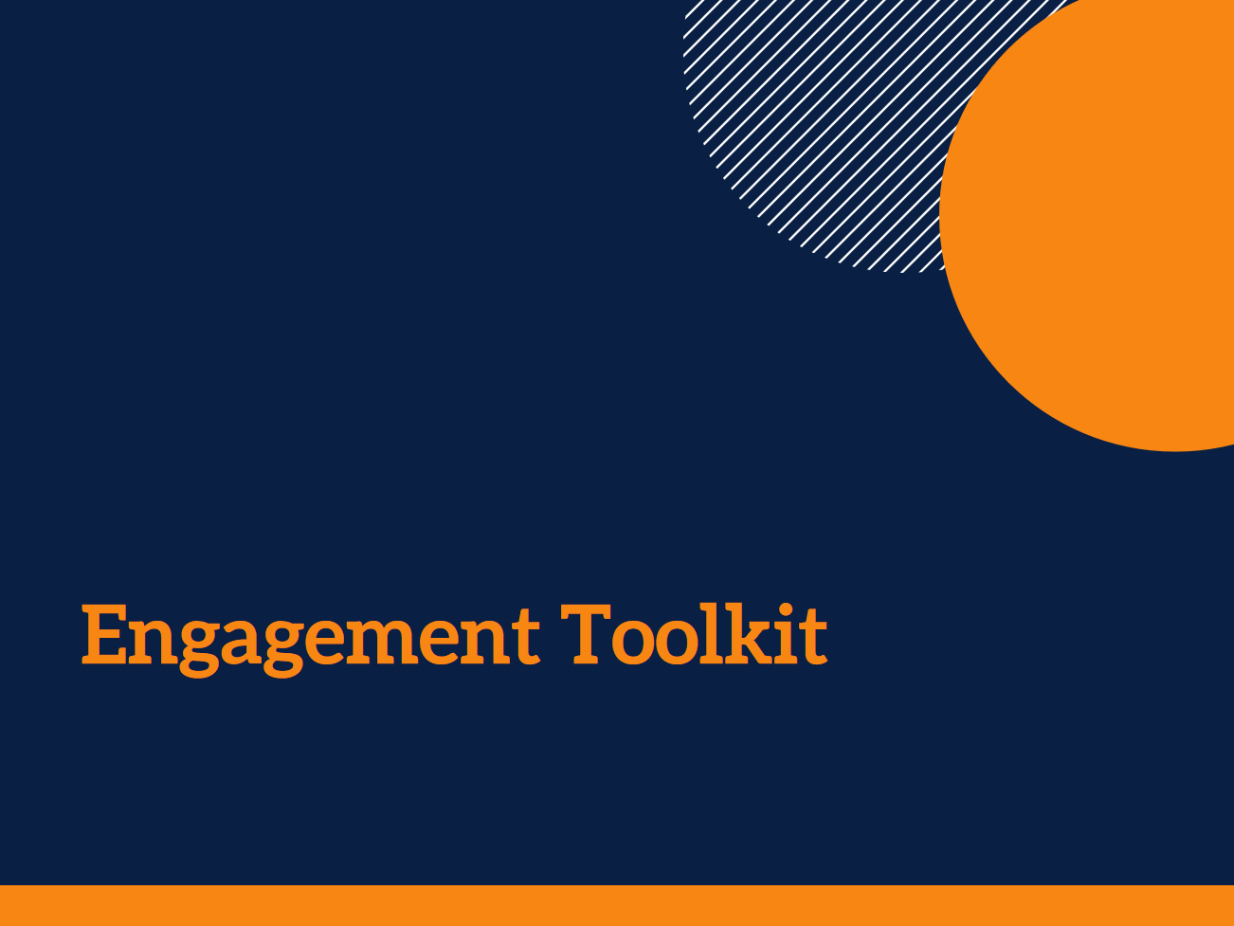

ENGAGEMENT MAPPING TOOL

Acknowledgments
There are a number of documents and practical guidelines that have been used to inform this Toolkit. The sources used here are listed in the References section at the end of the Toolkit.

The contributions of Stephanie Power, Dr Ally Gibson, a large number of service staff and managers, and the panel of academic and practice experts to the development of the Toolkit are gratefully acknowledged.

This research was funded by an Australian Research Council Discovery Early Career Researcher Award (DE140101503).

Author: Andrea Petriwskyj
© 2017 The University of Queensland, Brisbane, Australia
ABN 63 942 912 684, CRICOS Provider No: 00025B

This work is licensed under a Creative Commons Attribution-NonCommercial-NoDerivatives 4.0 International License. To view a copy of this license, visit https://creativecommons.org/licenses/by-nc-nd/4.0/.

This tool will help you to identify what engagement activity is already happening across the organisation.
There are two dimension to the Tool – who is involved or what level of decision it is, and what level of involvement people have.
To help you think through the activity that is already taking place, ask yourself:
What do we engage with consumers, families, and the community about? What kinds of information, issues, and decision making are we involved in with these different stakeholders?
You might find it helpful to refer to the What engagement methods could I use? tool to help jog your memory about some techniques you might already use. There are a few examples in the Tool to start you off.
Once you have completed your map, you may be able to see some gaps in your current engagement, or activities you would like to include in future.

 | When it involves an individual or their family | When it involves  our whole service | When it involves  the local community | When it involves  our whole organisation
When we just need to tell people about something.  We are not seeking their feedback, or trying to make a decision. | - Click here to enter text. |  |  | - E.g. Website
When we want to gather new ideas, or we are seeking feedback on an issue.  We keep full control of the decision. |  |  |  | - E.g. Consumer survey
When we need in-depth discussion with people about an issue.  We seek their input and influence on a decision. |  | - E.g. Consumer/ resident meetings
When we want to develop a solution in equal partnership with people. | - E.g. Collaborative care planning
When we want to empower people to generate the solution and manage the process themselves.
We assist as needed.

