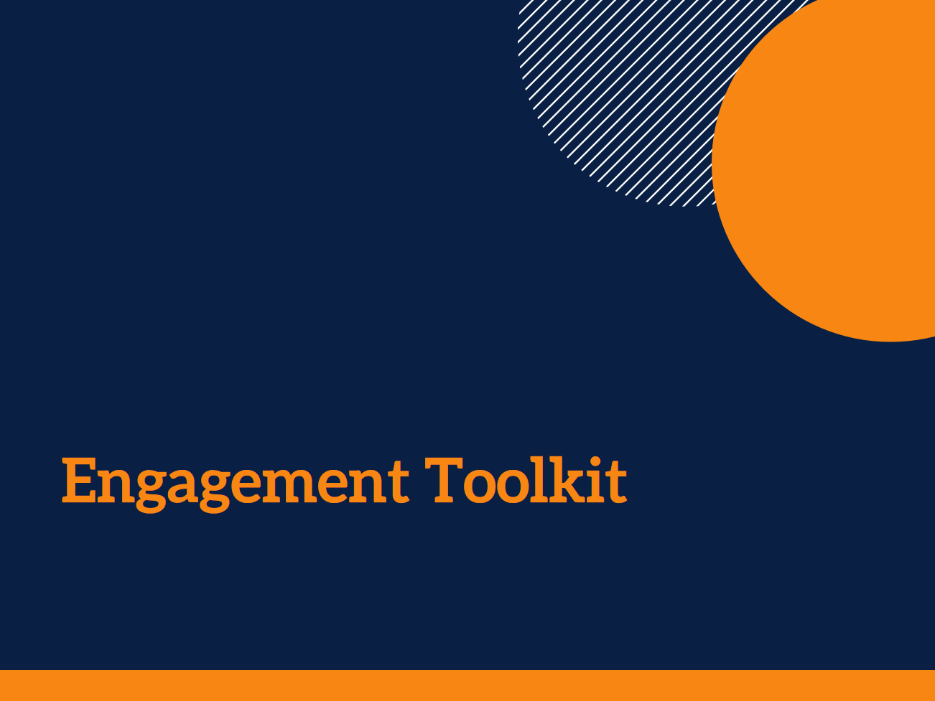

MONITORING AND EVALUATION TOOL

Author: Andrea Petriwskyj
© 2017 The University of Queensland, Brisbane, Australia
ABN 63 942 912 684, CRICOS Provider No: 00025B

This work is licensed under a Creative Commons Attribution-NonCommercial-NoDerivatives 4.0 International License. To view a copy of this license, visit https://creativecommons.org/licenses/by-nc-nd/4.0/.

Acknowledgments
There are a number of documents and practical guidelines that have been used to inform this tool. The sources used here are listed in the References section at the end of the Toolkit.

The contributions of Stephanie Power, Dr Ally Gibson, a large number of service staff and managers, and the panel of academic and practice experts to the development of the Toolkit are gratefully acknowledged.

This research was funded by an Australian Research Council Discovery Early Career Researcher Award (DE140101503).

Once you have begun implementing your project, you can use this tool to help you think through how it went, and whether you need to change something. Evaluation is an essential part of your project, to help you see what you have achieved and what isn’t working.
It is also important to evaluate along the way to see what you have achieved and to celebrate what you’ve accomplished. It is important to celebrate your achievements during your project so that you can feel confident you are making a difference.
You can use this tool at multiple points in your project to help you reflect and evaluate and make changes along the way.
The tool is designed to help you think through:
- What happened and what you have achieved
- What you found out from what happened
- What you might need to do differently and what you should do next

Monitoring and Evaluation Tool
Date of review
Enter the date.

What we did
Click here to enter text.

What happened
What we have achieved:

What didn’t go to plan:

What other people told us about how our activity went:

What we learned
New issues we identified:

New actions we need to take:

Budget review
Are we successfully sticking to our budget?
☐ Yes
☐ No
If not, what additional expenses do we need to include?

What we are going to do next | When it will be done | Who is responsible
 | Date  Date  Date  Date  Date  Date | Team member

