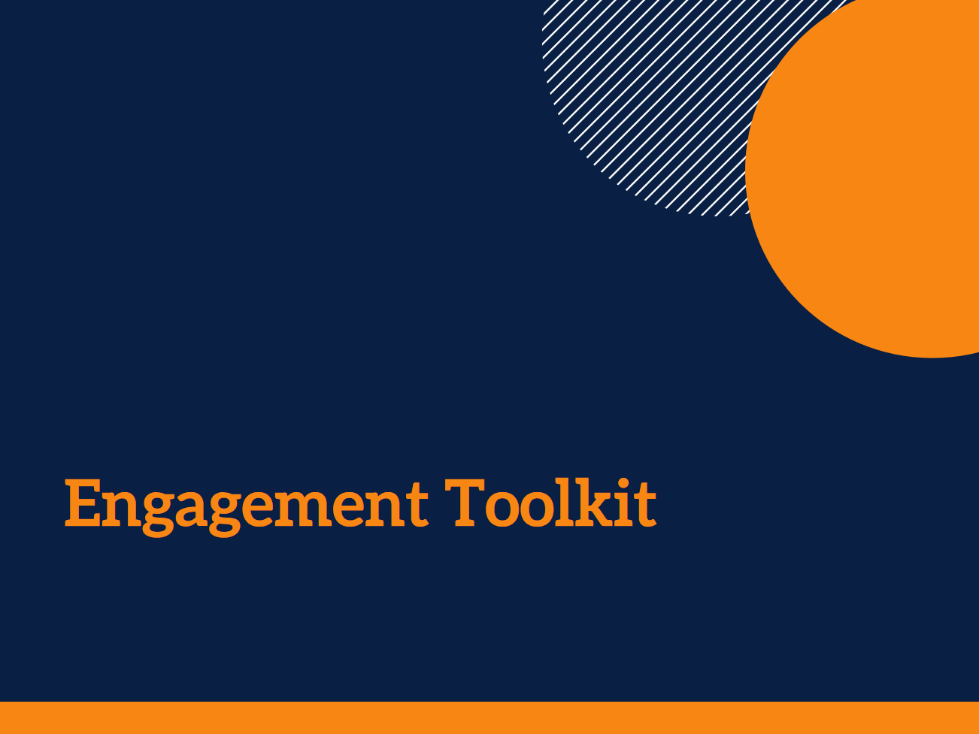

NEED FOR ACTION TOOL

Author: Andrea Petriwskyj
© 2017 The University of Queensland, Brisbane, Australia
ABN 63 942 912 684, CRICOS Provider No: 00025B

This work is licensed under a Creative Commons Attribution-NonCommercial-NoDerivatives 4.0 International License. To view a copy of this license, visit https://creativecommons.org/licenses/by-nc-nd/4.0/.

There are a number of documents and practical guidelines that have been used to inform this tool. The sources used here are listed in the References section at the end of the Toolkit.

The contributions of Stephanie Power, Dr Ally Gibson, a large number of service staff and managers, and the panel of academic and practice experts to the development of the Toolkit are gratefully acknowledged.

This research was funded by an Australian Research Council Discovery Early Career Researcher Award (DE140101503).

Acknowledgments
The Need for Action Tool is designed to help you to think about how you and other staff engage with your clients, and any issues you can see that need to be addressed.
Once you have mapped what is happening already using the Engagement Mapping Tool, you can use the Need for Action Tool to assess what needs to change.
You can click and type directly into the Tool.

Need for Action Tool

This tool will help you to think about how you and other staff engage with people, and any issues you can see that need to be addressed. You can complete it by yourself or as a group. This is also a useful tool to use in staff meetings to help facilitate discussion about issues staff are experiencing in their work. It can also be helpful to use the Engagement Mapping Tool to jog your memory about what you have already been doing.

Our current engagement
How we engage with people:
Click here to enter text.

What we engage with them about:

How we find out what they think about how we engage:

What needs to be changed
What people have told us about how we engage:

Issues we have identified:

What we can do about it
Things we can change:

Things we need to escalate to a higher level in our organisation:

