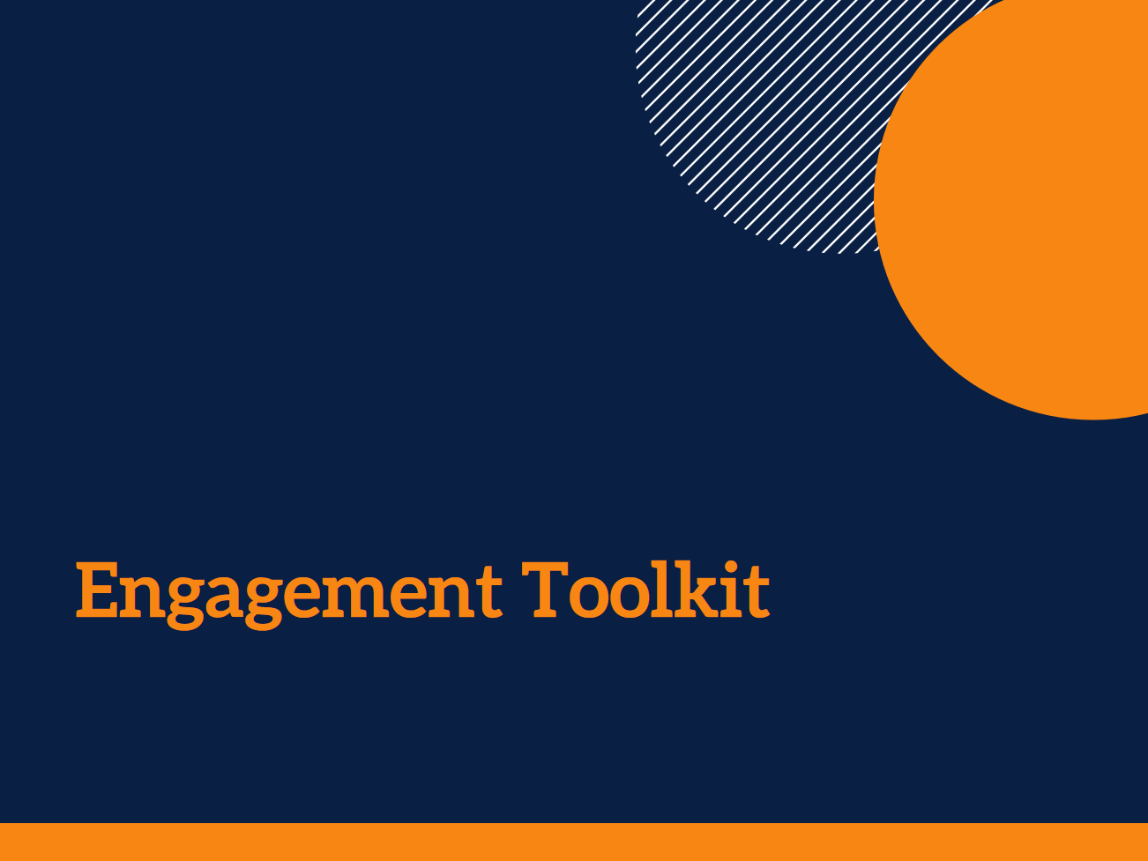

TEMPLATE FRAMEWORK

Acknowledgments
There are a number of documents and practical guidelines that have been used to inform this framework. The sources used here are listed in the References section at the end of the Toolkit.

The contributions of Stephanie Power, Dr Ally Gibson, a large number of service staff and managers, and the panel of academic and practice experts to the development of the Toolkit are gratefully acknowledged.

This research was funded by an Australian Research Council Discovery Early Career Researcher Award (DE140101503).

Author: Andrea Petriwskyj
© 2017 The University of Queensland, Brisbane, Australia
ABN 63 942 912 684, CRICOS Provider No: 00025B

This work is licensed under a Creative Commons Attribution-NonCommercial-NoDerivatives 4.0 International License. To view a copy of this license, visit https://creativecommons.org/licenses/by-nc-nd/4.0/.

This template framework will help you to develop an Engagement Framework and Strategy for your organisation.
The template steps you through the process of mapping current engagement practice, identifying gaps and desired changes, and choosing the level of engagement you would like to pursue for different purposes.
The template includes instructions throughout that you can delete from the document when you have completed them. The instructions point you to different tools you can use to complete each section of the framework document.
There is suggested wording included throughout the document. You can simply insert the name of your organisation wherever indicated, or you can alter the wording to suit your needs.
When you have completed the framework document, you can copy it into a new document and reformat it to suit your organisation’s needs and to reflect your own document style.

[Organisation]

Consumer Engagement Framework

About this document
The purpose of this framework
[Organisation] recognises the importance of effectively engaging with consumers, their families and support persons, and their communities. Engagement ensures opportunities for people to receive appropriate information and support, participate in decisions that affect their care and everyday lives, and drive or advise on [Organisation]’s service delivery, evaluation, planning and design. This framework is designed to support effective engagement practice.
Engagement can occur at any level of the organisation and can be used to inform our decision making, services, and practice – individually, within each service, in a local community, or organisation-wide. Consumers have an important role in the planning, delivery, and evaluation of services, as well as in the direction and evaluation of their own care. We are committed to ensuring that appropriate engagement activities occur at each of these levels.
This framework provides guidance on ways to ensure people have a genuine role at every level from their own individual needs through to organisational policies and processes. The framework will assist with identifying opportunities for involvement in all aspects of service design and delivery.
A commitment to engagement and participation means that people’s input is valued and that this is modelled throughout the organisation to all staff. We recognise that engagement is fundamental to fulfilling our mission and values, and we are committed to engagement practice that values the contribution of consumers throughout the organisation. Engagement and participation will be included in key [Organisation] policies and as part of planning processes and evaluation. This framework will inform how engagement is embedded in all of the organisation’s policies and processes.

Where this framework fits at [Organisation]
This framework connects with a number of [Organisation]’s policies, and our strategic and operational plan.
[Organisation] policy/ plan | Aspects of policy/ plan that intersect with this framework | How this framework informs the policy/ plan
[Organisation] strategic plan

Why we engage
Benefits of effective engagement
[Organisation] recognises the range of important benefits of effectively engaging with consumers, their families and support persons, and their communities.
These include:
- comprehensive, inclusive, accessible, and innovative services, with increased satisfaction with and uptake;
- a clearer understanding of people’s needs and wishes and greater insight into their experience, leading to informed decision making;
- better communication, resulting in greater trust;
- more informed and appropriate decision making for individuals, and increased support for their control over care planning and decision making, and in everyday decision making.

The legal and regulatory context for engagement
Effective engagement is essential to meet our obligations within the care system. There are a number of legislative and regulatory requirements that this framework is designed to help us meet. Some of these requirements refer specifically to consumer participation and involvement in decision making. Some refer to the provision of information, some refer to acting on requests, and some refer to working in partnership to make decisions.

Regulation or Standard | What this means for engagement
Aged Care Quality Standards | The Aged Care Quality Framework centres on consumer outcomes. Each standard is related to a consumer outcome and directly refers to consumers throughout the stated requirements. Across the standards, there is specific reference to:  - tailoring to consumers’ needs, wishes, and preferences,  - partnership approaches,  - supporting informed decision making and engagement with formal processes, and  - working with individuals and supporting them to maintain their identity and dignity,  - cultural safety, diversity, and inclusion.  Each of these reflects a need to engage more deeply with individuals to understand their needs and preferences not only in regard to care, but in regard to their participation in the service and system, and to work as equal partners and maintain ongoing dialogue with each person.
Charter of Care Recipients’ Rights and Responsibilities for Residential Care | Individuals’ rights include:  - full information,  - having their individual preferences taken into account,  - having control over, and to continue making decisions about their life,  - maintaining independence,  - being involved in the activities, associations and friendships of his or her choice, and to have access to services and activities available generally in the community,  - being consulted, and able to choose to have input into, decisions about the service,  - being able to complain and to take action, and having access to advocates and other avenues of redress.  Each of these refers to the ways in which the service is required to directly engage, or to provide and support avenues for the individual to engage. This goes beyond direct decisions about their care or everyday life, and goes beyond formal complaints mechanisms, to supporting control, autonomy, and freedom as well as citizenship within the service.
Charter of Care Recipients’ Rights and Responsibilities for Home Care | Individuals’ rights include:  - having their individual preferences respected  - being treated with dignity and respect, being free from abuse and exploitation, and not being made to feel they should be grateful  - having freedom of speech  - being able to complain and have complaints addressed without fear, and having access to advocates and other avenues of redress  - being able to set goals for their own care, make decisions, choose how care and services are provided and by whom,  - being able to determine the level of involvement they would like, and to choose a representative to be involved in decisions  - maintaining independence  - being given clear information about their care and services, costs and their budget, being helped to understand information, and being able to ask for a review or for other information including information about themselves and their care  Each of these rights refers to the choices and controls an individual should have, as well as the supports they have a right to expect or request. They are also about the way in which these are provided – ensuring respectful, open dialogue and relationships.

How we engage
Our staff are the key to engagement
Engagement can occur at any level of the organisation and involves staff in all roles. Engagement may not necessarily involve direct contact with individual consumers. It could involve, for example, information sharing through marketing materials or information sheets, or the development of web services, or communication about accounts or billing. It could involve direct discussion, collaboration, or partnership with one or many individuals at any given time. Engagement is therefore the responsibility of all [Organisation]’s staff. It is important that all staff have an understanding about what engagement means for their everyday work and how to implement it effectively.
Specific responsibility for engagement initiatives will depend on the purpose of the activity and at what level of the organisation it takes place. However, [Organisation] encourages all staff to consider how they can contribute within their own roles to our overall engagement approach, and how they can ensure that people always have someone to discuss issues or share ideas with. We support a “no wrong door” policy across our services.
Just as all staff may be involved in engagement initiatives, all staff are responsible for ensuring that information and feedback from these initiatives is collected. This information should be collated and fed back to [Organisation] management to inform decision making as well as future engagement initiatives. While engagement can be both formal and informal in practice, formal engagement initiatives should be documented to support evaluation and to inform reporting for accreditation and monitoring and to help staff learn for future engagement activities.
We support people to engage
[Organisation] will support its staff to undertake engagement and participation initiatives, and consumers will be supported to participate effectively. The efforts of staff and consumers as well as other stakeholders in contributing to these initiatives will be recognised and valued. This framework is designed to give a general grounding in what engagement looks like and the purposes it serves.
Any framework needs to be accompanied by practical support, mentoring, and training to assist staff to understand and implement the guidelines. We recognise the importance of providing training to support all staff in their engagement roles. We acknowledge the need for support, leadership and education to assist with staff developing a strong, responsive customer service focus, which includes appropriate responses to challenging situations and providing correct information. Mentoring in engagement by senior and experienced staff is an important part of continual development of engagement practice within [Organisation].
Empowering consumers is important to [Organisation], with good information, education and a strong service culture key to achieving this. Being flexible in how we engage, as well as providing any training or education that consumers need to engage effectively, is important. We recognise that sometimes people need support to be involved in formal processes. We also recognise that in order to be inclusive, we need to change how we do things rather than expecting people to always fit in with our expectations and processes. We are committed to being inclusive in how we engage, and to being flexible and changing our practice to ensure that no-one is excluded. We recognise that there is no-one who cannot be engaged or involved, but that some may need for us to change how we work to adequately support them.
We recognise that engagement begins before someone starts using a service, and may continue after they stop. It goes beyond good information sharing to dialogue and discussion, shared creation of solutions to issues, equal partnership in decision making, and empowerment of consumers to create and implement initiatives or solutions, and take control of processes. It also goes beyond supporting people to have control over or influence aspects of their own lives or care, and includes supporting people to be citizens in their service, the organisation, or their community, participating and contributing beyond their own care.
Engagement with family and friends is an important part of what we do and helps us to support individuals’ choice and autonomy. The expectations of families and support persons can affect decision-making, so the information they receive and their understanding about our services and the care system is vital. We are committed to ensuring that family members and support persons have accurate, timely information in a form and at a time that best supports their decision making, and ensuring that we understand their expectations. We also acknowledge that the transition into a care service can be challenging for family members and we seek to understand how we can help them to maintain engagement in the life of the service. We value staff-family relationships of warmth, trust and personal connection. This framework is designed to support engagement in a way that facilitates these relationships.
We work closely with our diverse partners and stakeholders
We know that the people we need to engage with are diverse, including not only in culture and language, but also in age, mental health, disability, care needs, sexuality, life experiences, skills and expertise, capacity, and preferences for how they engage. Different people need and want to engage differently. We are committed to being responsive in our engagement approach to the preferences and needs of consumers and the community, not only to our organisation’s needs.
Engagement processes must also be designed in a way that is inclusive of marginalised or isolated groups. It is important to link with organisations or agencies that work with, and represent, client groups who are at risk of being marginalised, face challenges to service access, or have poor health outcomes. We value these partnerships and see their development as an important part of our engagement processes. We recognise that consumers and community stakeholders should be involved in determining the strategic direction for engagement to ensure mechanisms are appropriate and accessible. This framework is designed to support the design of engagement initiatives that are appropriate and tailored.
Different stakeholders are important for different purposes of engagement. As well as consumers and their families and support persons, they may be information services, other service providers, policy makers, consumer groups, or representatives, for example. It is important to identify their stake or interest in engagement, and their required or preferred level of influence in decision making. Engagement activities should be designed with reference to existing [Organisation] service profile information, including client demographics, needs, and service use to ensure that appropriate clients and community stakeholders are involved.

Engagement principles
Commitment to involvement
We recognise the benefits of engagement and we are committed to ensuring consumers’ right to have a say in how our services are run.
We will be open to consumers’ views, and willing to respond and make change.
We will ensure transparent communication that allows all involved to be informed and voice their own opinions.
We will work to ensure shared ownership of decisions and solutions.
Transparency
We will be clear about what we are trying to achieve with our engagement activities and whether or not there are opportunities to influence the outcome.
We will openly and promptly report on how participation did or did not contribute to changes or decision making.
Feedback will be shared with all those involved as well as all those affected. Feedback will be given in ways that meet people’s varied needs, abilities, and values. We will ensure people have the opportunity to discuss this feedback.
We will undertake on-going evaluation and monitoring of engagement initiatives and incorporate our learnings into future initiatives. We will involve consumers in this monitoring and evaluation and ensure we share the outcomes so that everyone can learn from them.
Respect, inclusion, and fairness
We will provide sufficient different opportunities for participation that respect and recognise people’s diverse abilities and experiences and the different ways people engage in decision making processes.
We will engage in a way that demonstrates and promotes mutual respect for and dignity of all involved, and values every person equally.
We will ensure necessary training, education and support for both staff and consumers, and will develop organisational policies and processes to support engagement.

Mechanisms for engagement
Engagement initiatives should be designed in the context of existing mechanisms and strategies in place in the organisation. There may be opportunities to build upon, strengthen, or replace approaches that have been used.

! It is important to map current consumer and community engagement activities across the organisation. Once you know what is already taking place, you can review these to see where any changes may need to be made.
Use the Engagement Mapping Tool to help you identify what your organisation already does.

Importantly, this framework recognises the importance of engagement and participation both in individuals’ own care and the broader system and broader community. Engagement occurs at the individual, local, service and organisational level. Engagement can be reactive or proactive and can be active or passive.
Whilst different types of engagement call for greater or less involvement, no type is meant to be better than another. The type should be chosen according to the purpose of engagement and should match the degree to which people wish to be involved and on the main purpose of engagement in that case: whether the aim is to simply inform or educate people, to gain feedback, or to go further in collaborating and partnering with people and seeking joint solutions.
[Organisation] recognises that engagement occurs across all of these spheres and at every level of the organisation. Engagement can be an individual or group activity, it may be one-off or ongoing, it may be formal or informal, and it occurs every day across the organisation.
The levels of engagement, what aims they help to achieve, and examples of the kinds of mechanisms we may use, are detailed below. There are some challenges to implementing these different mechanisms effectively. It is vital that in deciding on strategies, potential barriers to effectiveness and existing strengths within the organisation are considered. More detail on each mechanism can be found in the Client Engagement Toolkit in the What engagement methods could I use? and Which engagement method should I use? tools.

What level of engagement? Explanatory chart

Element | What it is | When to use it
Inform/Educate | Convey facts or describe a project, service, or policy or inform people about services, decisions, or changes | There is no opportunity to influence the final outcome, or there is no decision to be made
Gather information/ Consult | Find out people’s views and ideas, gather information, and use this to improve services or practice | The issues are still being explored, or there is no firm commitment by the organisation to use the information to change the outcome
Discuss/ Involve | Two-way information exchange and discussion about potential solutions and ideas among, and with, people | Those involved have a vested interest and there is genuine opportunity for them to influence the outcome, but the organisation needs to keep control over the decision
Collaborate/ Partner | People shape decisions and solutions in equal partnership with the organisation | The issues are complex and need a joint approach, and there is commitment that solutions generated together will be implemented and will be respected by all parties
Empower | People are empowered to come up with solutions and manage the process themselves | The people involved are willing and able to take control of solutions and there is a firm commitment by the organisation to support and implement the solutions others come up with
(DHHS Tasmania, 2009; Health Canada, 2000)
Our strategy

! Identify what level of engagement you would like people to have in your organisation. This may be different depending on whether the issue or decision involves individuals, the service, the broader community, or the whole organisation. Consider how different stakeholders might be involved at every stage including service planning and design, service delivery, and service monitoring and evaluation.
Make sure you are clear about the purpose of each level of engagement and why it is appropriate for the kinds of decisions you are making.
Collect feedback from the different stakeholders about their preferences for involvement and what support they might need to be involved.
Refer to the regulatory requirements to ensure you are doing all you can to address them through your engagement activities.
Some areas you should consider have been pre-populated in the table. You can add any that are relevant to your organisation.
Our strategy
 | We will involve people up to the level of… | The reason we have chosen this level is…
When it involves an individual or their family
Care planning
Lifestyle and activity planning
When it involves a whole service
Recruitment and HR management
Lifestyle and activity planning
Service evaluation
When it involves the local community
Service planning
Service delivery
When it involves our whole organisation
Policy development
Business planning
Project planning
Strategic planning

! Once you have decided what level of involvement will be most appropriate, you can develop a more specific strategy for particular outcomes you are planning for the coming year/s.
Identify the specific outcomes and outputs you have planned. Include those at the Individual, service, community, and organisational level. Refer to your strategic and operational plans.
Use the What engagement methods could I use? and Which engagement method should I use? tools to identify appropriate mechanisms for engagement.
Identify how information and feedback from engagement activities will be fed back into decisions and will provide direction for the organisation, and how information and feedback will be communicated to all the stakeholders.

Planned outcome | Mechanism/s we will use | How input will inform the outcome | How we will report back

! Use the Action Planner to plan the specifics of each engagement activity as it comes time to implement them.

Outcome and performance measures
Ongoing assessment of engagement activities will contribute to performance monitoring and reporting for [Organisation].
Because of the range of ways that engagement can occur, the various purposes of engagement, and because participation may be continuous or ongoing, a range of measures may be appropriate to the engagement strategies. Some points to consider include (from SCIE, 2007):
Why?
- We will carefully consider our reasons for evaluating each activity to ensure we are collecting the right information
What and how?
- We will link outcomes and measures to strategic and operational plans.
- We will include indicators that measure whether the activity reached the target audience, and met its purpose.
- We will include indicators that measure how engagement has led to outcomes in areas such as: care; quality and safety; communication; efficiency and resources; appropriateness, accessibility or timeliness of services; and health literacy. We will choose indicators that reflect what kinds of change we expected to see, and who we expected that change to affect.
- We will evaluate both the effects and the process of engagement. We will consider whether each opportunity for engagement has been real and meaningful.
- We will include both the negative and positive messages about our activity.
When?
- For each activity, we may be interested in short term, long term, or both short and long term change or outcomes. Evaluation may also be once-off or ongoing, depending on what is being evaluated and why. We will consider these different purposes in timing of evaluation.
Who?
- We will carefully choose who will conduct the evaluation, and consider whether they will provide an evaluation that is effective and independent.
- We will provide them with the skills or training they need, and ensure adequate resources.
- We will be careful to protect those involved in the evaluation.
- We will carefully consider the differences in power between different people involved – such as consumers, care and nursing staff, managers, and families – which can affect evaluation.
Closing the loop
- In order to learn from evaluation, it is important to report back on what we find. In our evaluation plan, we will identify how and when we will report back to clients, the community, staff, and the organisation about our engagement activity.

! The Action Planner contains sections that will help you plan your evaluation. You can use the Monitoring and Evaluation Tool to monitor your activity as you conduct it.
Recommended Resources
There are a number of documents which offer comprehensive explanations of the range of available engagement strategies, what level they target, and practical guidelines. These documents have been used to inform this framework.
These include:
- Dialogue by Design (2012). A handbook of public and stakeholder engagement. London: Dialogue by Design.
- Health Canada (2000). Health Canada policy toolkit for public involvement in decision making. Ottawa: Minister of Public Works and Government Services Canada.
- Department of Health and Human Services Tasmania [DHHS] (2009). Your care, your say: Consumer and community engagement. Hobart: Department of Health and Human Services Tasmania.
- Consumer Focus Collaboration (2000). Improving health services through consumer participation: A resource guide for organisations. Canberra: Commonwealth Department of Health and Aged Care.
- Health Service Executive (2010). Service user involvement methods: A guidance document. Dublin: Health Service Executive.
- National Resource Centre for Consumer Participation in Health (2003). Organisational self-assessment and planning tool for consumer and community participation: A tool for organisations involved in health policy and education. LaTrobe University.
- NSW Health (1999). Community consultation and participation resource kit for area health service managers and project leaders. North Sydney: NSW Health Department.
- Queensland Health (2002). Consumer and community participation toolkit for Queensland Health staff. Queensland: Queensland Health.
- Queensland Health (2010). Consumer engagement framework. Brisbane: Queensland Health.
- Queensland Health (2010). Consumer and community engagement and patient involvement and participation in health service planning, delivery and evaluation. Brisbane: Queensland Health.
- Queensland Health (2012). Developing a consumer and community engagement strategy: A toolkit for hospital and health services. Brisbane: Queensland Health.
- Social Care Institute for Excellence (2007). Developing measures for effective service user and carer participation. London: Social Care Institute for Excellence.
- Tasmanian Council of Social Service (2012). Consumer engagement handbook for HACC services in Tasmania. Battery Point: TasCOSS.

Acknowledgments
The contributions of Stephanie Power, Dr Ally Gibson, a large number of service staff and managers, and the panel of academic and practice experts to the development of the Toolkit are gratefully acknowledged.

This research was funded by an Australian Research Council Discovery Early Career Researcher Award (DE140101503).

